Project Development Phase Sprint – 3

# Program:

#include <WiFi.h> #include <PubSubClient.h> #include <DHT.h> WiFiClient wifiClient; String data3;

#define DHTTYPE DHT11 #define DHTPIN 4

#define MQTPIN 34

DHT dht(DHTPIN, DHTTYPE);

#define ORG "v6wg8x"

#define DEVICE_TYPE "projectFinal" #define DEVICE_ID "FinalDeliverable" #define TOKEN "A1ymH))p*JB&iMWNpY" #define speed 0.034

void callback(char* topic, byte* playload, unsigned int payloadLength); char server[] = ORG ".messaging.internetofthings.ibmcloud.com";

char publishTopic[] = "iot-2/evt/Data/fmt/json";

char topic[] = "iot-2/cmd/test/fmt/String"; char authMethod[] = "use-token-auth";

char token[] = TOKEN;

char clientId[] = "d:" ORG ":" DEVICE_TYPE ":" DEVICE_ID;

PubSubClient client(server, 1883, callback , wifiClient); void publishData();

String command; String data = "";

long duration; float dist;

void setup()

{

Serial.begin(115200); dht.begin(); wifiConnect(); mqttConnect();

}

void loop() { publishData(); delay(500);

if (!client.loop()) { mqttConnect();

}

void wifiConnect() {

Serial.print("Connecting to "); Serial.print("Wifi"); WiFi.begin("JerroldWi-Fi","75779901");

while (WiFi.status() != WL_CONNECTED) { delay(500);

Serial.print(".");

}

Serial.print("WiFi connected, IP address: "); Serial.println(WiFi.localIP());

}

void mqttConnect() {

if (!client.connected()) {

Serial.print("Reconnecting MQTT client to "); Serial.println(server); while (!client.connect(clientId, authMethod, token)) {

Serial.print("."); delay(500);

}

initManagedDevice(); Serial.println();

}

}

void initManagedDevice() {

if (client.subscribe(topic)) { Serial.println("IBM subscribe to cmd OK");

} else {

Serial.println("subscribe to cmd FAILED");

}

}

void publishData()

{

int sensorValue = analogRead(MQTPIN); //MQT 135 connected to GPIO 34 (Analog ADC1_CH6)

Serial.print("AirQua="); Serial.print(sensorValue, DEC); Serial.println(" PPM");

float humid = dht.readHumidity();

float temp = dht.readTemperature(true); String payload = "{\"Humidity\":"; payload += humid;

payload += "}";

if (client.publish(publishTopic, (char*) payload.c_str())) { Serial.println("Publish OK");

}

payload = "{\"Temperature\":"; payload += temp;

payload += "}";

if (client.publish(publishTopic, (char*) payload.c_str())) { Serial.println("Publish OK");

}

payload = "{\"Air Quality\":"; payload += String(sensorValue); payload += "}";

if (client.publish(publishTopic, (char*) payload.c_str())) { Serial.println("Publish OK");

}

void callback(char* subscribeTopic, byte* payload, unsigned int payloadLength) {

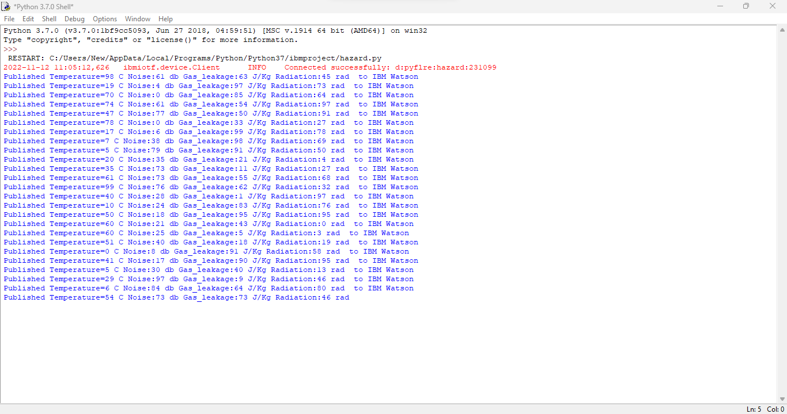

Serial.print("callback invoked for topic:"); Serial.println(subscribeTopic);

for (int i = 0; i < payloadLength; i++) { dist += (char)payload[i];

}

Serial.println("data:" + data3); if (data3 == "lighton") {

Serial.println(data3);

}

data3 = "";

}

# Output: